Executive Summary
Product Optimization & Revenue Contribution Analysis
Afficionado Coffee Roasters
Prepared by: Aimee Susan Joseph

Background:
Afficionado Coffee Roasters operates across various store locations, where they offer a diverse menu of specialty coffee and related products. Regardless of their strong transaction volumes, the business lacked structured visibility into which products were truly driving revenue and which products were underperforming. This analysis was done to provide a data-driven intelligence to help support smarter menu-driven decisions, improve revenue performance and reduce operational inefficiencies caused by an overcrowded menu.

Business Snapshot:
Metric | Value
Total Revenue
Total Transactions
Total Units Sold
Unique Products Analyzed

Key Findings:
- A Small Number of Products Drive the Majority of Revenue
Out of the full product menu, only 42 products are responsible for 80% of the revenue. This implies a strong revenue concentration pattern, which means that the business is heavily dependent on a handful of hero products for its financial performance.
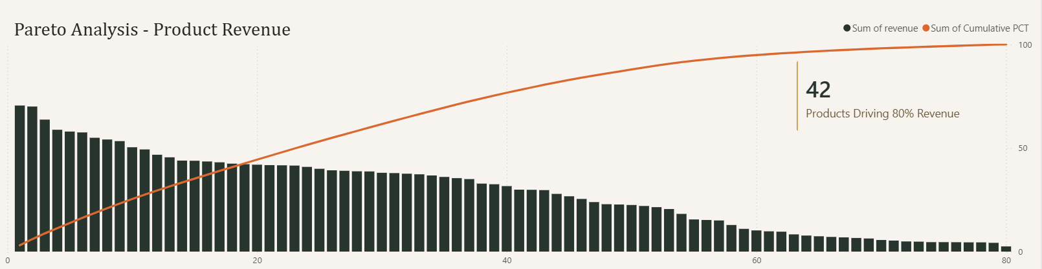

- Hero Products Identified
The top-revenue generating products include Sustainably Grown Organic Lg ($21,152), Dark Chocolate Lg ($ 21,006), Latte Rg ($19,112), Cappuccino Lg ($17,642) and Morning Sunrise Chai Lg ($17,384). These products represent the core of the business and should be prioritized in menu placement, promotions and stock management.
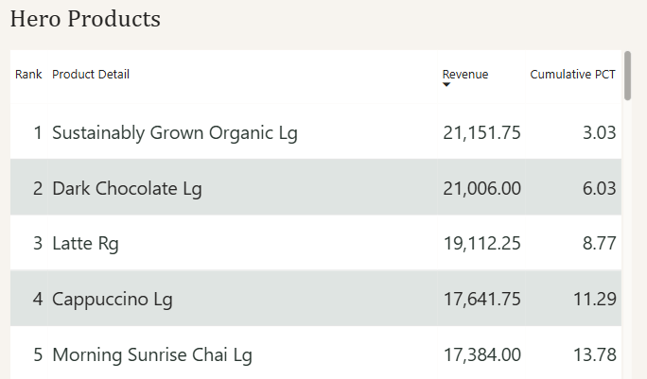

- Category Revenue Dependency
Revenue is not evenly distributed across product categories. The Coffee category contributes the largest share of revenue at 38.63%, indicating a significant business dependency, also given the fact that the company is into coffee sales. Should this category underperform due to supply, pricing or demand shifts, the overall revenue would heavily be impacted.
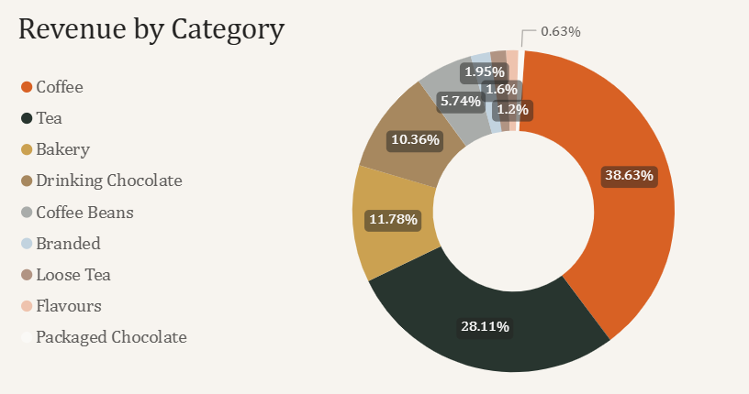

- Long-Tail Products Presents a Menu Simplification Opportunity
36 products contribute less than 20% of total revenue combined. These long-tail products occupy menu space, add operational complexity, and slow service without meaningful revenue return. They represent a clear opportunity for menu review and simplification.
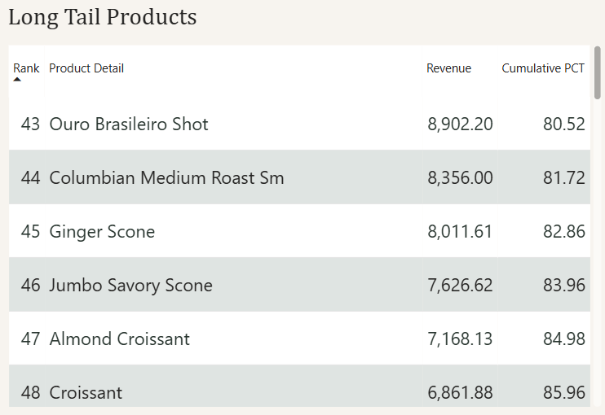

- Volume Does Not Always Equal Revenue
Analysis revealed mismatches between product popularity and revenue contribution. Certain high-volume products generate disproportionately low revenue, while some lower-volume products carry higher revenue weight. This suggests pricing and promotion strategies for specific products could be revisited to better align sales volume with revenue impact.

Recommendations:
Based on the insights above, the following actions are recommended:
- Prioritize Hero Products: Feature top revenue-driving products prominently on the menu and invest in their promotion to protect and grow the revenue base.
- Review Long-Tail Products: Perform a focused review of the 36 underperforming products. Consider removing low-impact items, redesigning them or running targeted promotions to improve their contribution.
- Diversify Category Dependency: Given the heavy reliance on the Coffee category, invest in growing revenue from other categories to reduce concentration risk.
- Revisit Pricing on High-Volume, Low-Revenue Products: Products with strong sales volume but weak revenue contribution should be evaluated for price adjustments to improve their overall impact.

Conclusion:
The interactive Power BI and Streamlit web application dashboards developed as part of this project provide Afficionado Coffee Roasters with ongoing, real-time visibility into product and revenue performance. These tools enable the business to move away from intuition-driven menu decisions toward a structured, data-informed approach, supporting sustainable revenue growth and a more efficient, customer-focussed menu strategy.

